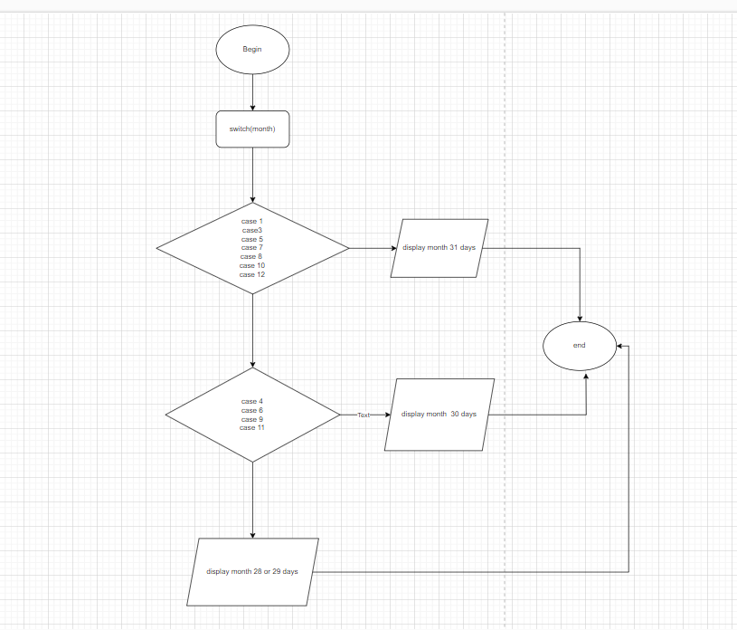

Begin

Swich(month)

Case 1

Case 3

Case 5

Case 7

Case 8

Case 10

Case 12

display 31 days

Break;

Swich(month)

Case 4

Case 6

Case 9

Case 11

display 30 days

Break;

Default;

Display 28 or 29 days